**Problem 2:**

1. **Construct a histogram of this variable by use of the hist command.**
2. **Summarize this variable by the summary command.**
3. **Use the table command to construct a frequency table of the individual values of Dvds that were observed. If one constructs a barplot of these tabled values by use of the command**

**barplot(table(Dvds))**

**one will see that particular response values are very popular. Is there any explanation for these popular values for number of DVDs owned?**

**Code:**

library(LearnBayes)

data(studentdata)

studentdata[1,]

hist(studentdata$Dvds)

summary(studentdata$Dvds)

table(studentdata$Dvds)

barplot(table(studentdata$Dvds))

**Output:**

> library(LearnBayes)

> data(studentdata)

> studentdata[1,]

Student Height Gender Shoes Number Dvds ToSleep WakeUp Haircut Job Drink

1 1 67 female 10 5 10 -2.5 5.5 60 30 water

> hist(studentdata$Dvds)

> summary(studentdata$Dvds)

Min. 1st Qu. Median Mean 3rd Qu. Max. NA's

0.00 10.00 20.00 30.93 30.00 1000.00 16

> table(studentdata$Dvds)

0 1 2 2.5 3 4 5 6 7 8 9 10 11 12 13 14

26 10 13 1 18 9 27 14 12 12 7 78 3 20 7 4

15 16 17 17.5 18 20 21 22 22.5 23 24 25 27.5 28 29 30

46 1 3 1 4 83 3 3 1 3 2 31 3 1 1 45

31 33 35 36 37 40 41 42 45 46 48 50 52 53 55 60

1 1 12 4 1 26 1 1 5 1 2 26 1 2 1 7

62 65 67 70 73 75 80 83 85 90 97 100 120 122 130 137

1 2 1 4 1 3 4 1 1 1 1 10 2 1 2 1

150 152 157 175 200 250 500 900 1000

6 1 1 1 8 1 1 1 1

> barplot(table(studentdata$Dvds))

**ScreenShot:**

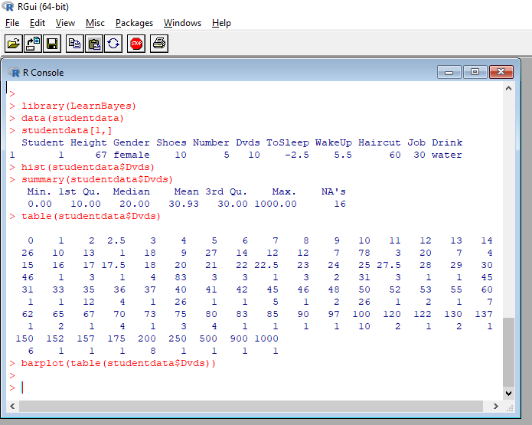

hist(studentdata$Dvds)

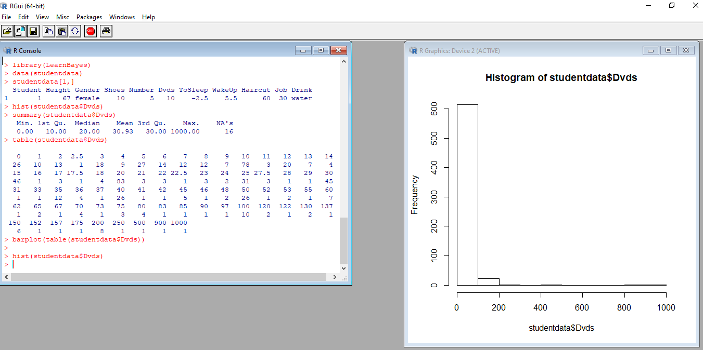

barplot(table(studentdata$Dvds))

